- processid
INPUT:
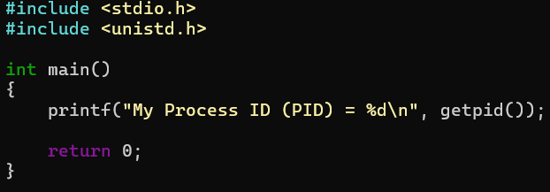
OUTPUT:
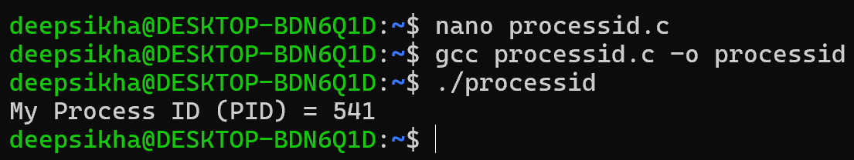
- creating child using fork()
INPUT:
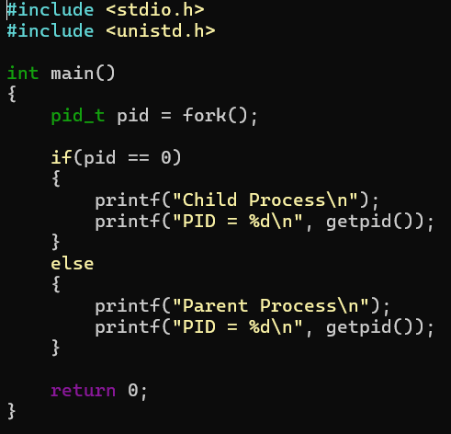

OUTPUT:
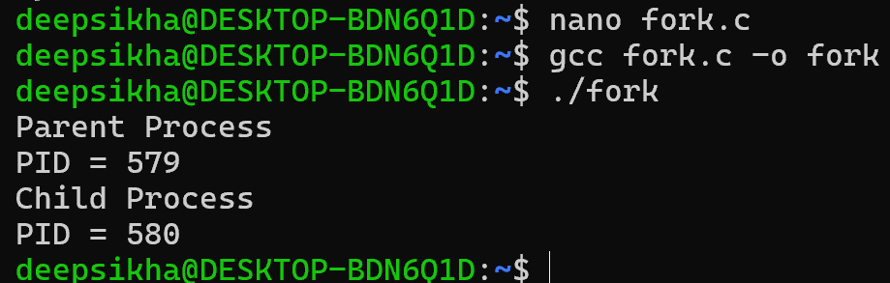

- Parent Waits for Child (wait())
INPUT:
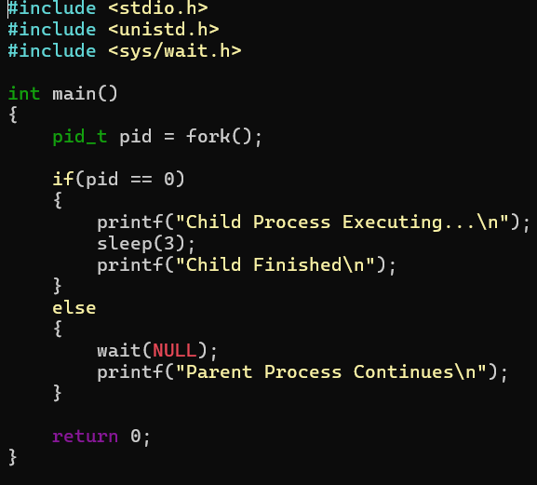
OUTPUT:
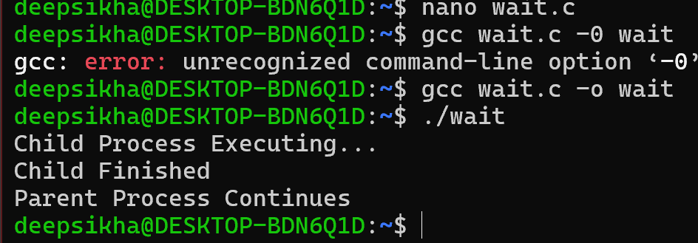

- Multiple Child Processes
INPUT:
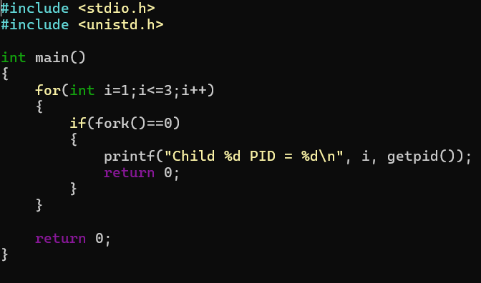
OUTPUT:
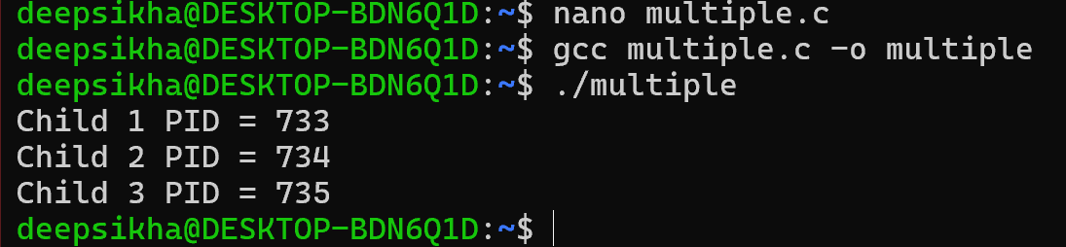
- Execute linux command using exclp()
INPUT:
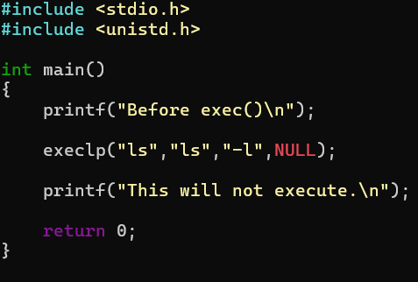

OUTPUT:
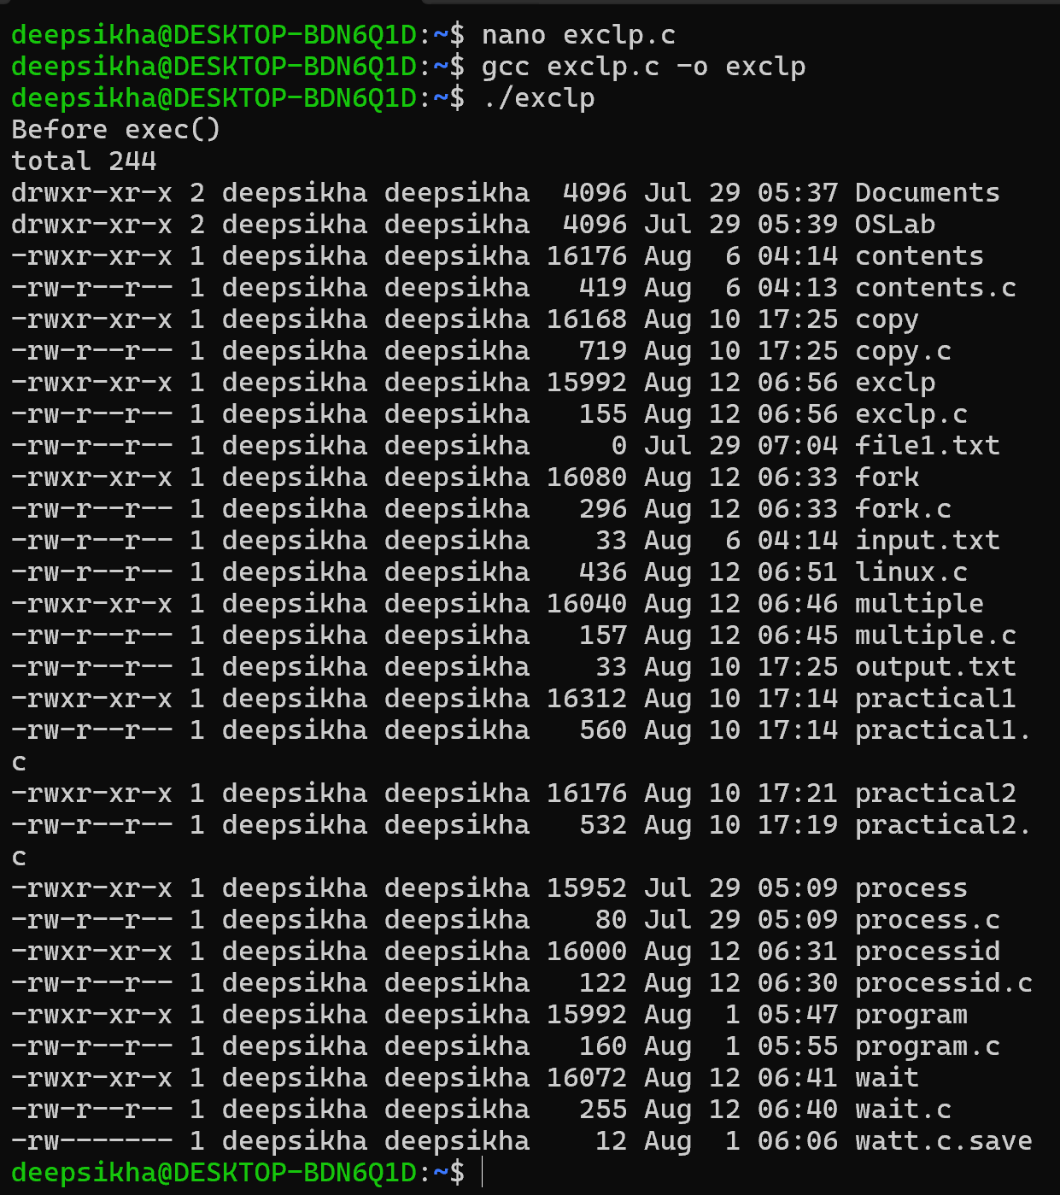
- Parent and Child Executing Concurrently
INPUT:
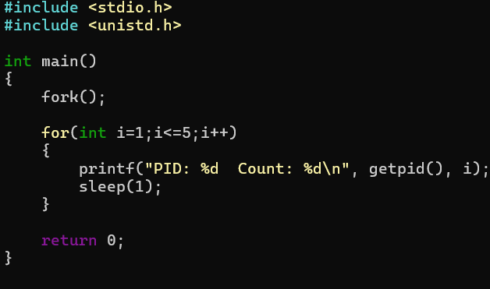
OUTPUT:
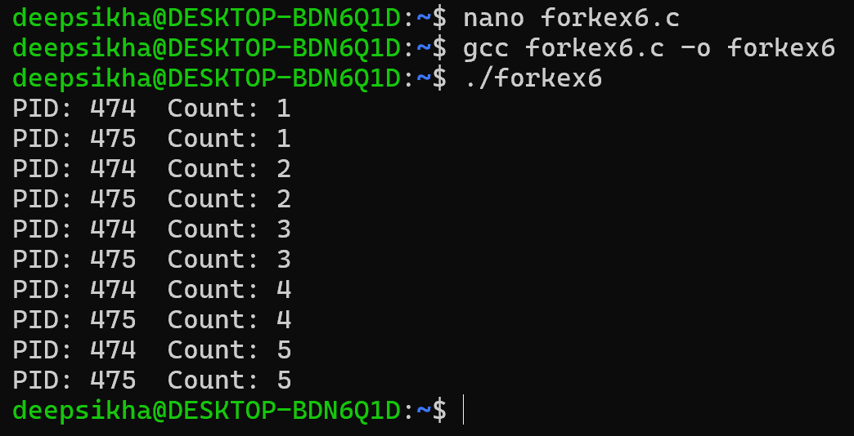
- Zombie Process
INPUT:
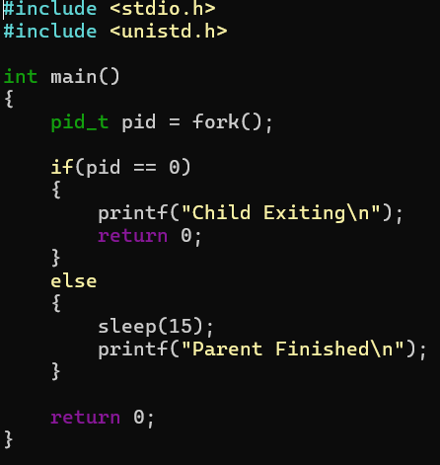
OUTPUT:
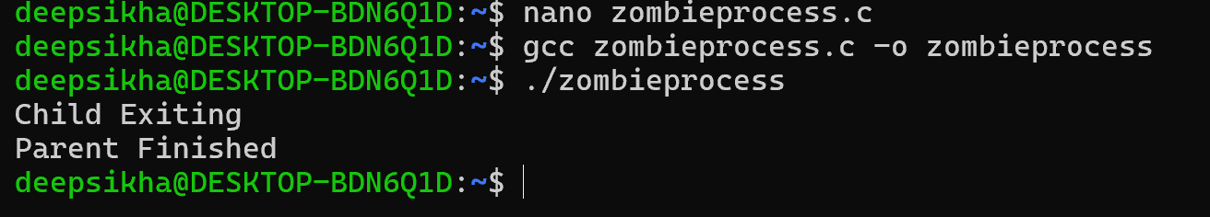
- OrphanProcess
INPUT:
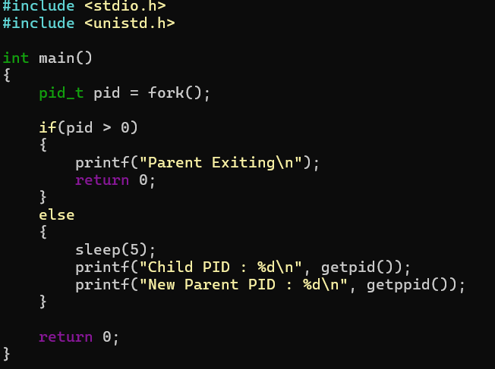
OUTPUT:
